
Tripoli Motor Testing Division
223 NC Highway 54 West
Chapel Hill, NC 27514
(919) 357 5681 (c)
December 6, 2022

Gary Rosenfield
RCS Rocket Motor Components, Inc.
2113 West 850 North Street
Cedar City, UT 84721

Dear Mr. Rosenfield,

The Aerotech K62N-P single-use motor was tested on December 4, 2022 and complies with NFPA 1125. The motor is certified for hobby rocketry use by the members of the Tripoli Rocketry Association and all approving organizations with reciprocal certifying agreements.

Motor Manufacturer RCS Rocket Motor Components, Inc.
Manufacturer’s Designation K62N-P [single use, DMS]
Propellant Warp Nine
TMT Nomenclature 1438 K63

Diameter 2.125” 53.98 mm
Overall Length 14.734” 374.25 mm
Outside the MMT 0.995”† 25.27 mm†
† = an estimate: tested motors were supplied without external thrust collar

Loaded Mass 2.815 lb 1276.9 g
Propellant Mass 1.832 lb* 831 g*
Burnout Mass 0.820 lb 372.1 g
* = data provided by manufacturer

Burn time 23.1 ± 1.40 sec

Total Impulse 323.4 ± 3.85 lbf.s 1438.5 ± 17.08 N.s
Max Impulse 58.2 ± 3.09 lbf 258.7 ± 13.75 N
Average Impulse 14.10 ± 1.04 lbf 62.54 ± 4.64 N
Number of Motors Tested 3

Nominal Measured
Delay Time Data n.a. -

Casing Temp. [NFPA 1125 7.4.1] Passed

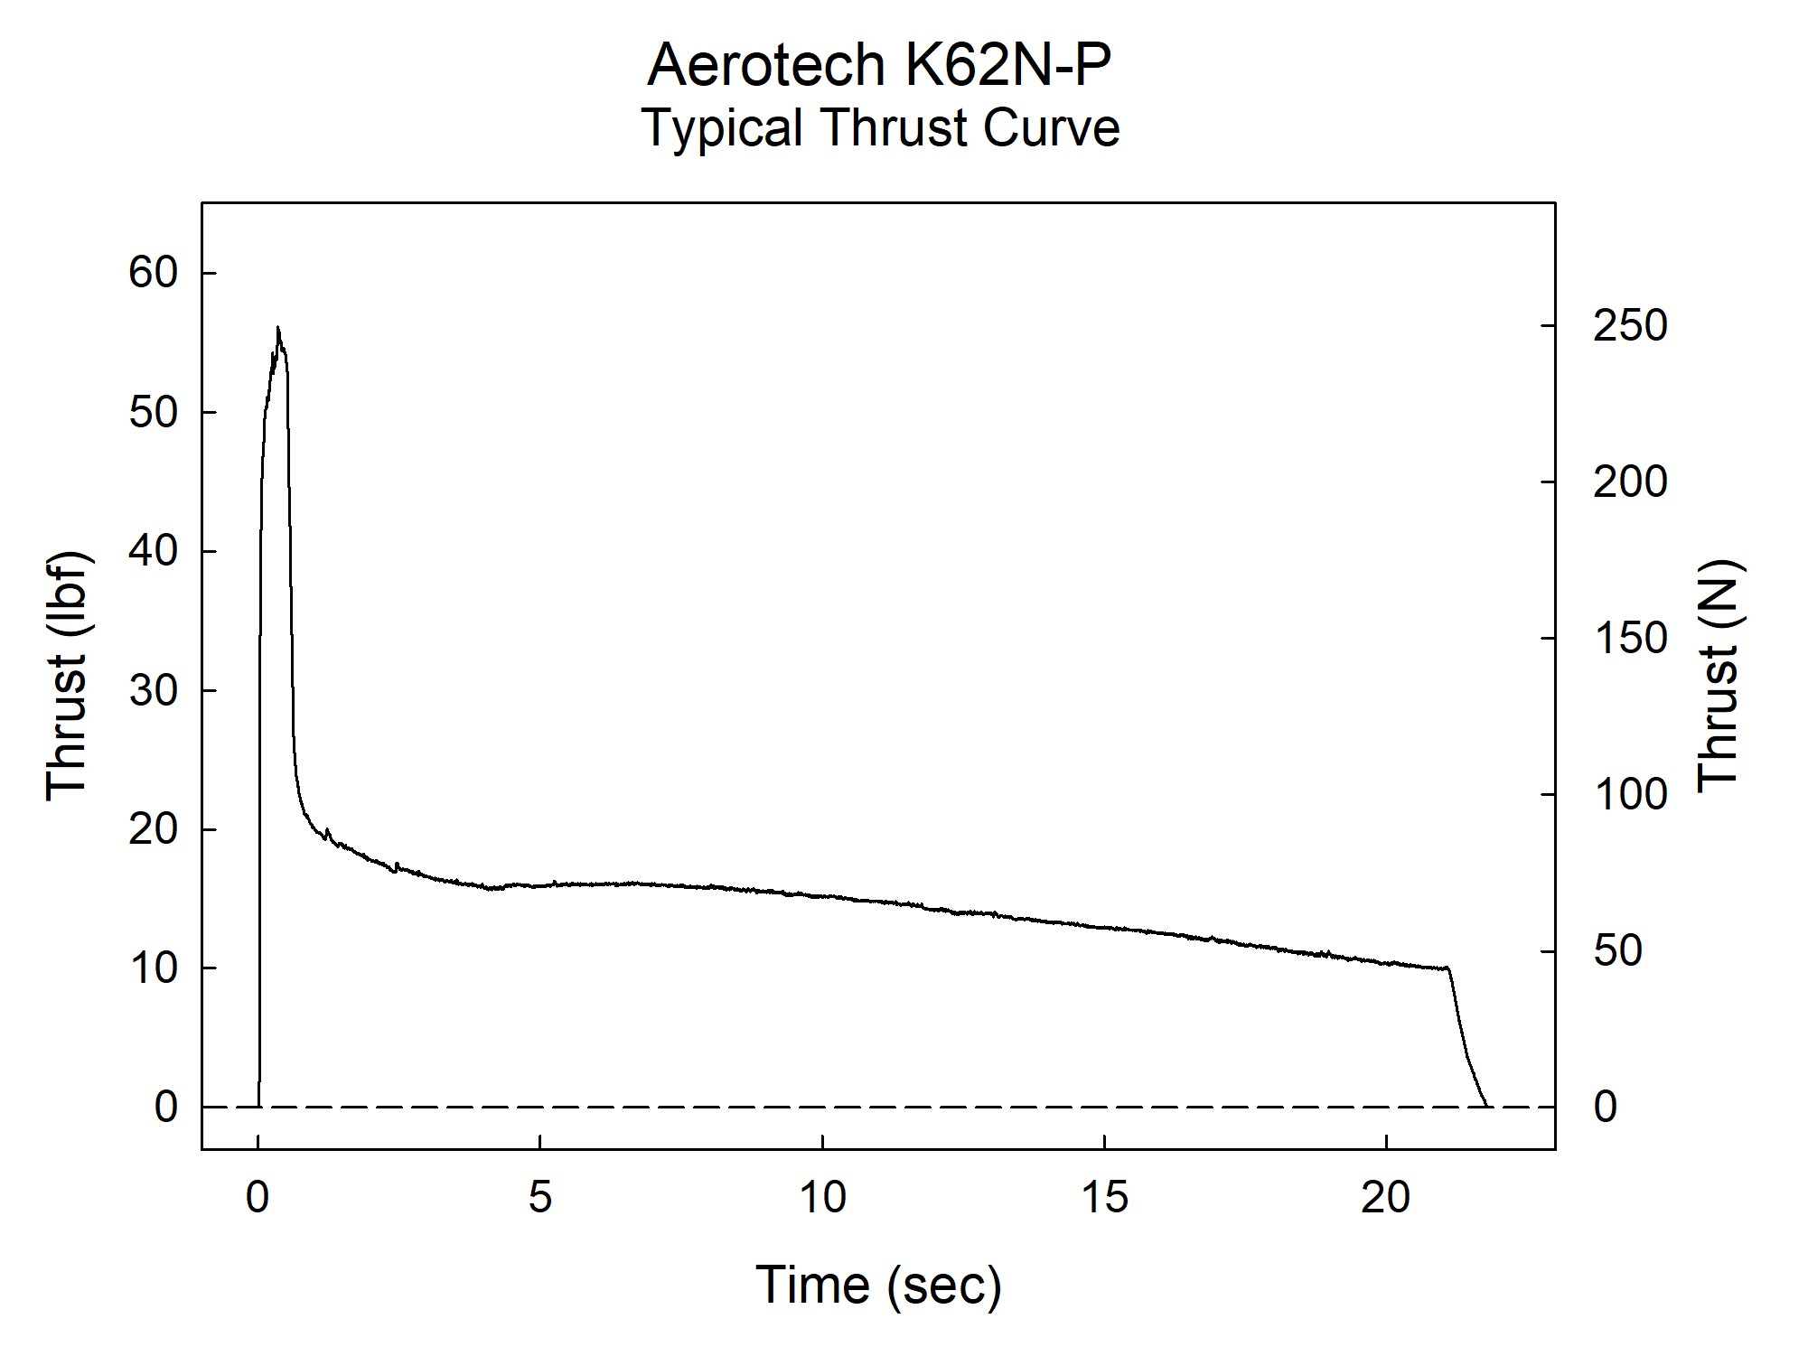

Sincerely,

Alan C. Whitmore
Chair, Tripoli Motor Testing

